Dishan Sivakumaran – Software Architect / Practice Manager
I started at Merkle in June 2015 (at that time called Namics) as Senior Software Engineer. Since then I learned a lot in various fields and technologies and my focus now is on Salesforce. My main job now goes more into Software Architecture. I’m based in Belgrade now and leading the Salesforce team here.
I have 9 years of experience in the IT industry and within those 2+years in the Salesforce ecosystem.
I design solutions for businesses that help them increase efficiency, reach more customers, decrease manual labour and overall make their business more profitable.

Iva Mijovic – Salesforce Software Engineer

I joined the company in January 2021. I am working as a Software Engineer for Salesforce on various projects. I have 5 years of experience in Salesforce ecosystem, and a total of around 10 years in business. I worked on a lot of different projects in different areas: automotive, agriculture, finance, betting, beauty, and medical industry for clients from Serbia, USA, Canada, and Nigeria. Beside Salesforce, during my career I worked in 2 other CRM systems and tested many different solutions.

Philipp Gort – Managing Director Serbia
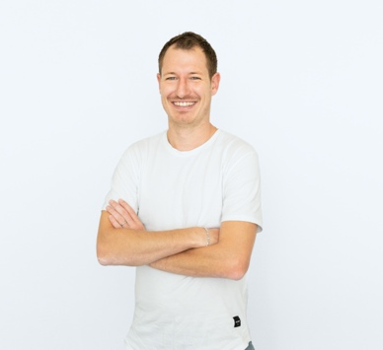
I started with the company in 2014 as a Project Manager in Switzerland. In the first five years I managed various projects and clients. The projects were ranging from mobile applications to content management systems to very design focused projects. Among the clients were banks, retailers and public companies.
During this time, I learned the dependencies between client management and leading a project team and the communication in between.
Since 2019, I’m the Managing Director of Merkle Serbia. In my role I’m responsible for the strategic development of our office in Belgrade and all our teams that are here.

Martin Sebala - Managing Consultant / Practice Group Manager
Head of Salesforce delivery team who has spent more than 17 years working in diverse technologies and environments, such as e-commerce, CRM, ERP, web and various IT systems, focused on projects and continuous delivery. Ambitious, results-driven team manager with a proven track record in successful change management, communication, and presentation.

Dušica Veličković – Senior Talent Acquisition Partner
I graduated from the Faculty of Philosophy, Psychology department. I started my career in 2016, and today, I am working as Senior Talent Acquisition Business Partner at Merkle. It is a fancy title and a fancy position - I am focusing on the process of selection and recruitment, and making sure we hire only great candidates. Gathering all valuable information about employees and market trends is also a big part of my job. My interests lie within the field of recruitment, people development and employee satisfaction.

